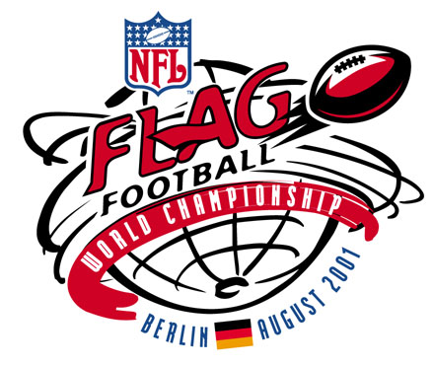

FOR IMMEDIATE RELEASE CONTACT: PETE ABITANTE – NFL (212/450-2065)
NFLI-4 8/13/01 MICHAEL SIGNORA – NFL (212/450-2076)
RON HOWARD – PHILADELPHIA EAGLES (215/339-5469)
JULIE DUBIN – PHILADELPHIA EAGLES (215/356-7479)

PHILADELPHIA EAGLES HOST TEAM USA AT TRAINING CAMP;

RUNNEMEDE (NJ) EAGLES TO COMPETE IN

NFL FLAG FOOTBALL WORLD CHAMPIONSHIP, AUGUST 21-25

The Philadelphia Eagles will welcome the Runnemede (NJ) Eagles to training camp at Lehigh University on Wednesday, August 15.

The boys from Runnemede – who named their team the Eagles after their favorite NFL squad – will represent the United States at the second annual NFL Flag Football World Championship on August 21-25 in Berlin, Germany.

“We are looking forward to having the young players from Runnemede here at training camp,” said Philadelphia Eagles head coach ANDY REID. “We are anxious to give them a great sendoff and wish them good luck as they compete on behalf of the United States at the Flag Football World Championship.”

The Runnemede team will watch the Eagles morning practice session and then Coach Reid and selected players will address the squad.

Runnemede qualified for the World Championships by winning the NFL Flag National Championship in Orlando, Florida last December. The Eagles advanced to Orlando after winning the Baltimore/Washington DC regional tournament, one of several held in various geographic regions around the country. To sign up for NFL Flag leagues in the United States, please call 1-800-NFL-SNAP or long on to playfootball.com.

In the German capital city, teams of 12-14 year-olds from 10 countries – Australia, Austria, Canada, Germany, Japan, Korea, Mexico, Spain, Thailand and the United States – will compete for the title won last year by the ‘Roo Boys’ of Melbourne, Australia.

“The NFL Flag Football World Championship is one of the highlights of the NFL’s efforts to develop football globally,” said DOUG QUINN, Senior Vice President of NFL International. “This tournament is a tribute to the youth around the world that play flag football and to the volunteers and school administrators that help make their participation so enjoyable.”

